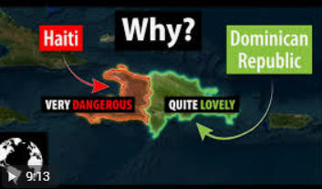
Consider all the Factors why on an island would one side be so lovely on one side and the other side Dangerous?

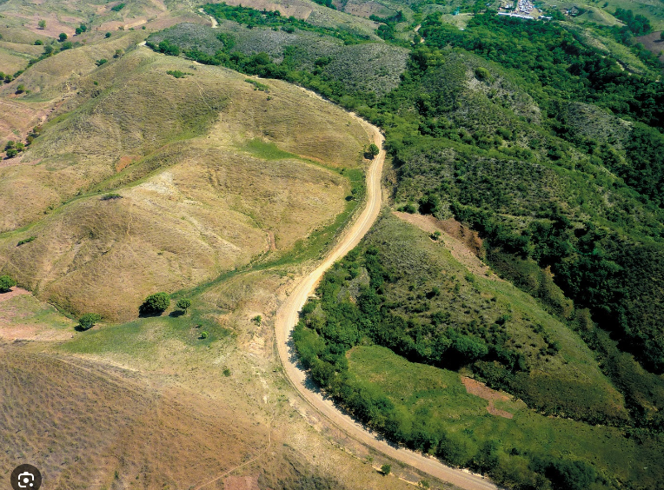

Students will research for 15 minutes and explore the possibilities to why one side of the island could be beautiful and why the other is barren. Have students place possibilities why this phenomenon occurs on this tropical island. Have students place these on a post it and place on the board…. ( These post its allow for the water cycle to be revisited, specific Heats, plate tectonics, ultimately leading to a scientific concept called Windward/Leeward or “Rain Shadow Effect”)
So based on what the students explore of this phenomena and there is so much that integrates into this lesson possible concepts could be
- Tropical Zone by latitude
- Sun hitting darker objects increases absorbition
- Page 19 ESRT Wind belts and Hadley currents
- Plate tectonics leads to orogeny
- Windward and leeward
- More and More



Personally I would take a few moments to discuss Plate tectonics with a small clip from you tube on Plateteconics. “Demolition Derby”
plate tectonics - YouTube

OperationsInc Recruiting Services (youtube.com)

Once all the post its are handed in discuss geographically on what is primarly causing the climate change on the island… This could lead into a cause and effect model…..

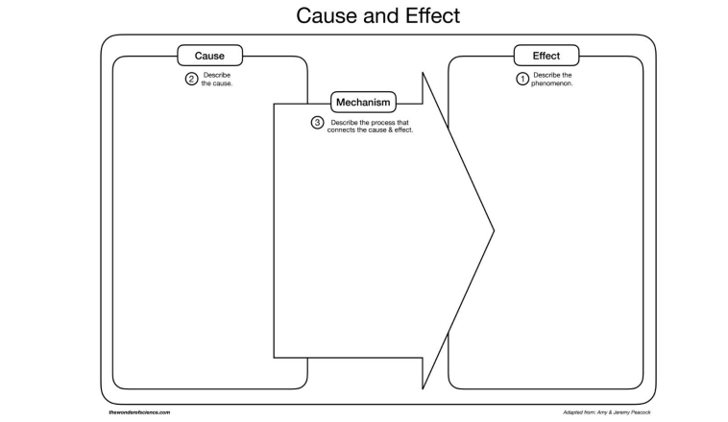
Reviewing the concepts of the water cycle and how the sun plays a major role in evaporation and atmosphere cools for condensation might be very valuable path… Vocabulary sheet might be helpful.
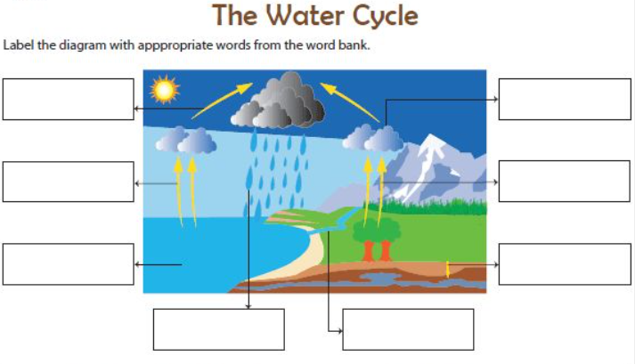

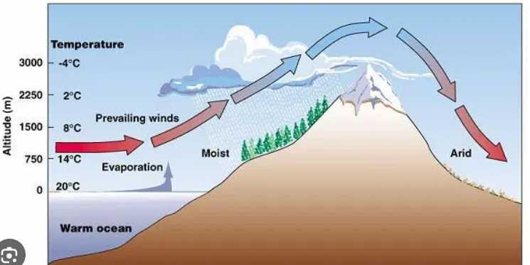

One Thing that is possible here is looking at the water cycle diagram and the windward/leeward and develop a comparison between them. Look for similarities and differences… Students after a brief explanation about the mechanics should be able to label which side is Haiti and which side is Dominican Republic.

Closure: Would love to explore possible solutions to this issue both politically and scientifically. Can both sides of the mountain chain ever get along. Politics aside is there a way that both can benefit from the climate that is induced by the topography?

